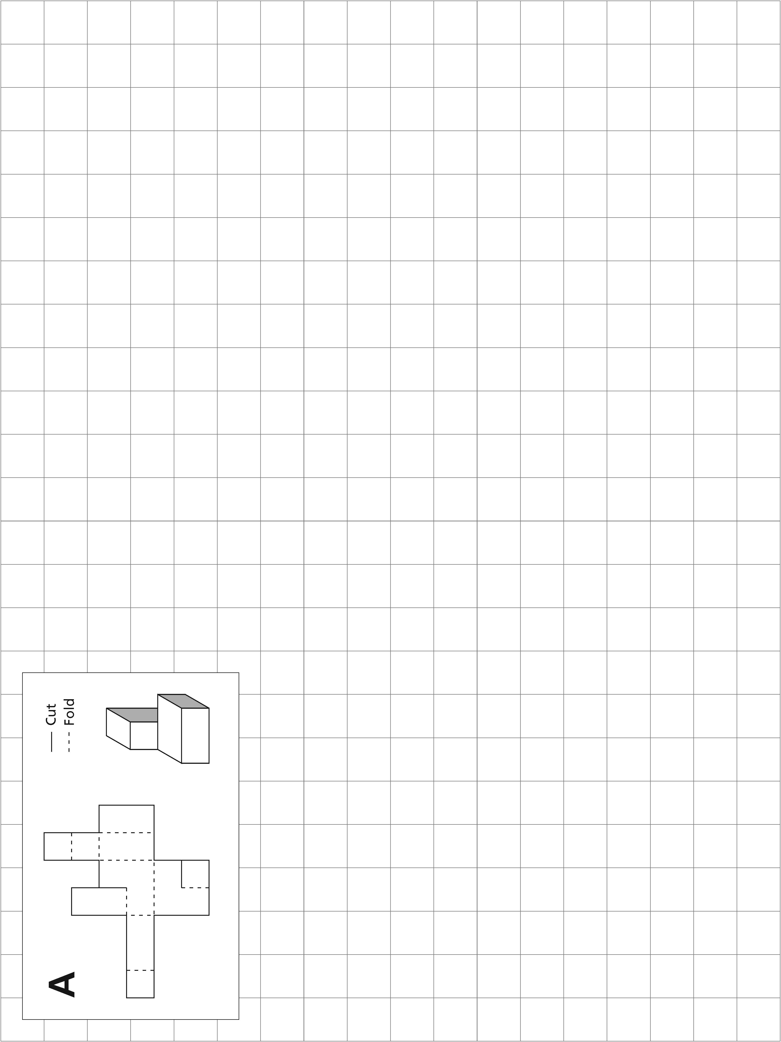

**Unit 1** The Puzzle Cube

**Lesson 2** Solving 1-Step Equations

1–46

Student Resource 2.2

**Unit 1** The Puzzle Cube

**Lesson 3** Solving 2-Step Equations

Worksheet: Rough Sketch–Net A

Directions

The following is a rough sketch of a net that will fold into a 3-D object. Write an expression for the perimeter of the net and simplify that expression. Then use the given information to write an equation for each variable. Solve the equations. Finally, calculate the exact perimeter of the net. Some of the work is already done for you.

All measurements are in centimeters (cm).

Assume that all lines are straight and that all corners are 90 degrees.

Not drawn to scale.

**Equation for Net A:**

|  |  |  |  |
| --- | --- | --- | --- |
| x) | *x* + 6 + 6 | = | 21 |
|  | *x* + 12 | = | 21 |
|  | *x* + 12 − 12 | = | 21 − 12 |
|  | *x* | = | 9 |
| y) |  | = |  |
|  |  | = |  |
|  |  | = |  |
|  |  | = |  |
| z) |  | = |  |
|  |  | = |  |
|  |  | = |  |
|  |  | = |  |



21

18

12

6

3

3

3

6

*y*

*y*

*y*

*y*

*y*

*y*

*z*

*x*

*x*

A

3

3

|  |  |  |  |  |
| --- | --- | --- | --- | --- |
| Expression for Perimeter: | | 3 + *x* + *y* + *z* + 3 + 3 + *y* + 3 + *y* + 3 + *y* + 6 + *y* + 6 + *y* + *x* | | |
| Simplified Expression for Perimeter: | | |  |  |
| Perimeter: | 1–53 | | |  |

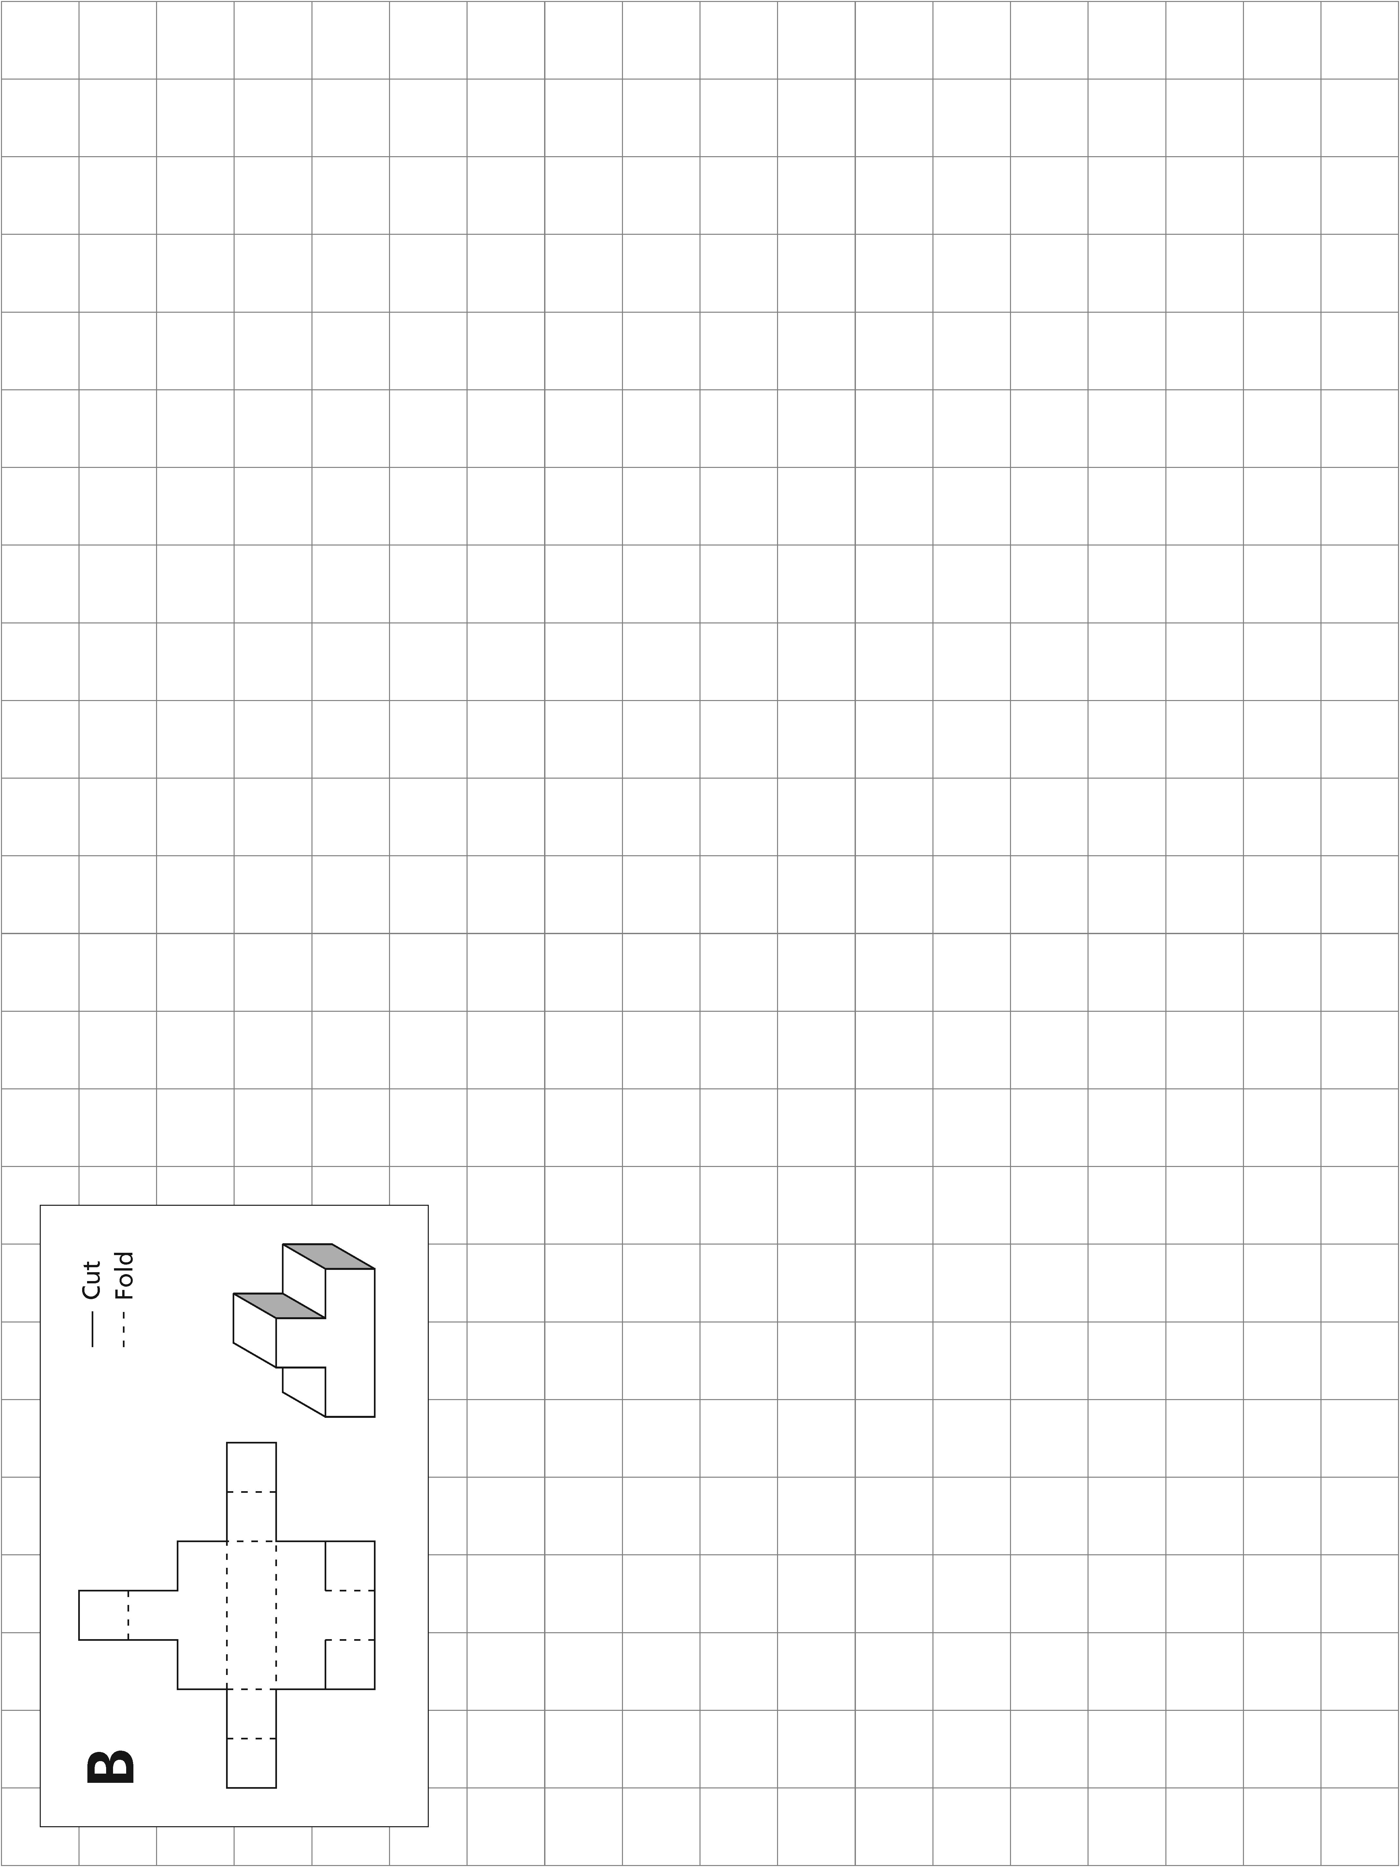

1–46

**Unit 1** The Puzzle Cube

**Lesson 2** Solving 1-Step Equations

Student Resource 3.1

**Unit 1** The Puzzle Cube

**Lesson 3** Solving 2-Step Equations

Worksheet: Rough Sketch–Nets B and C

Directions

The following are rough sketches of nets that will fold into 3-D objects. Write an expression for the perimeter of the net and simplify that expression. Then use the given information to write an equation for each variable. Solve the equations. Finally, calculate the exact perimeter of the net.

All measurements are in centimeters (cm).

Assume that all lines are straight and that all corners are 90 degrees.

Not drawn to scale.



21

18

15

B

*y*

*y*

*y*

*y*

2*y*

3

3

3

5*x*

5*x*

2*y*

2*y*

2*y*



5*x*

 + 3

**Equation for Net B:**

|  |  |  |  |
| --- | --- | --- | --- |
| x) |  | = |  |
|  |  | = |  |
|  |  | = |  |
|  |  | = |  |
| y) |  | = |  |
|  |  | = |  |
|  |  | = |  |
|  |  | = |  |
| z) |  | = |  |
|  |  | = |  |
|  |  | = |  |
|  |  | = |  |

|  |  |  |  |  |
| --- | --- | --- | --- | --- |
| Expression for Perimeter: | |  | | |
| Simplified Expression for Perimeter: | | |  |  |
| Perimeter: |  | | |  |

1–59

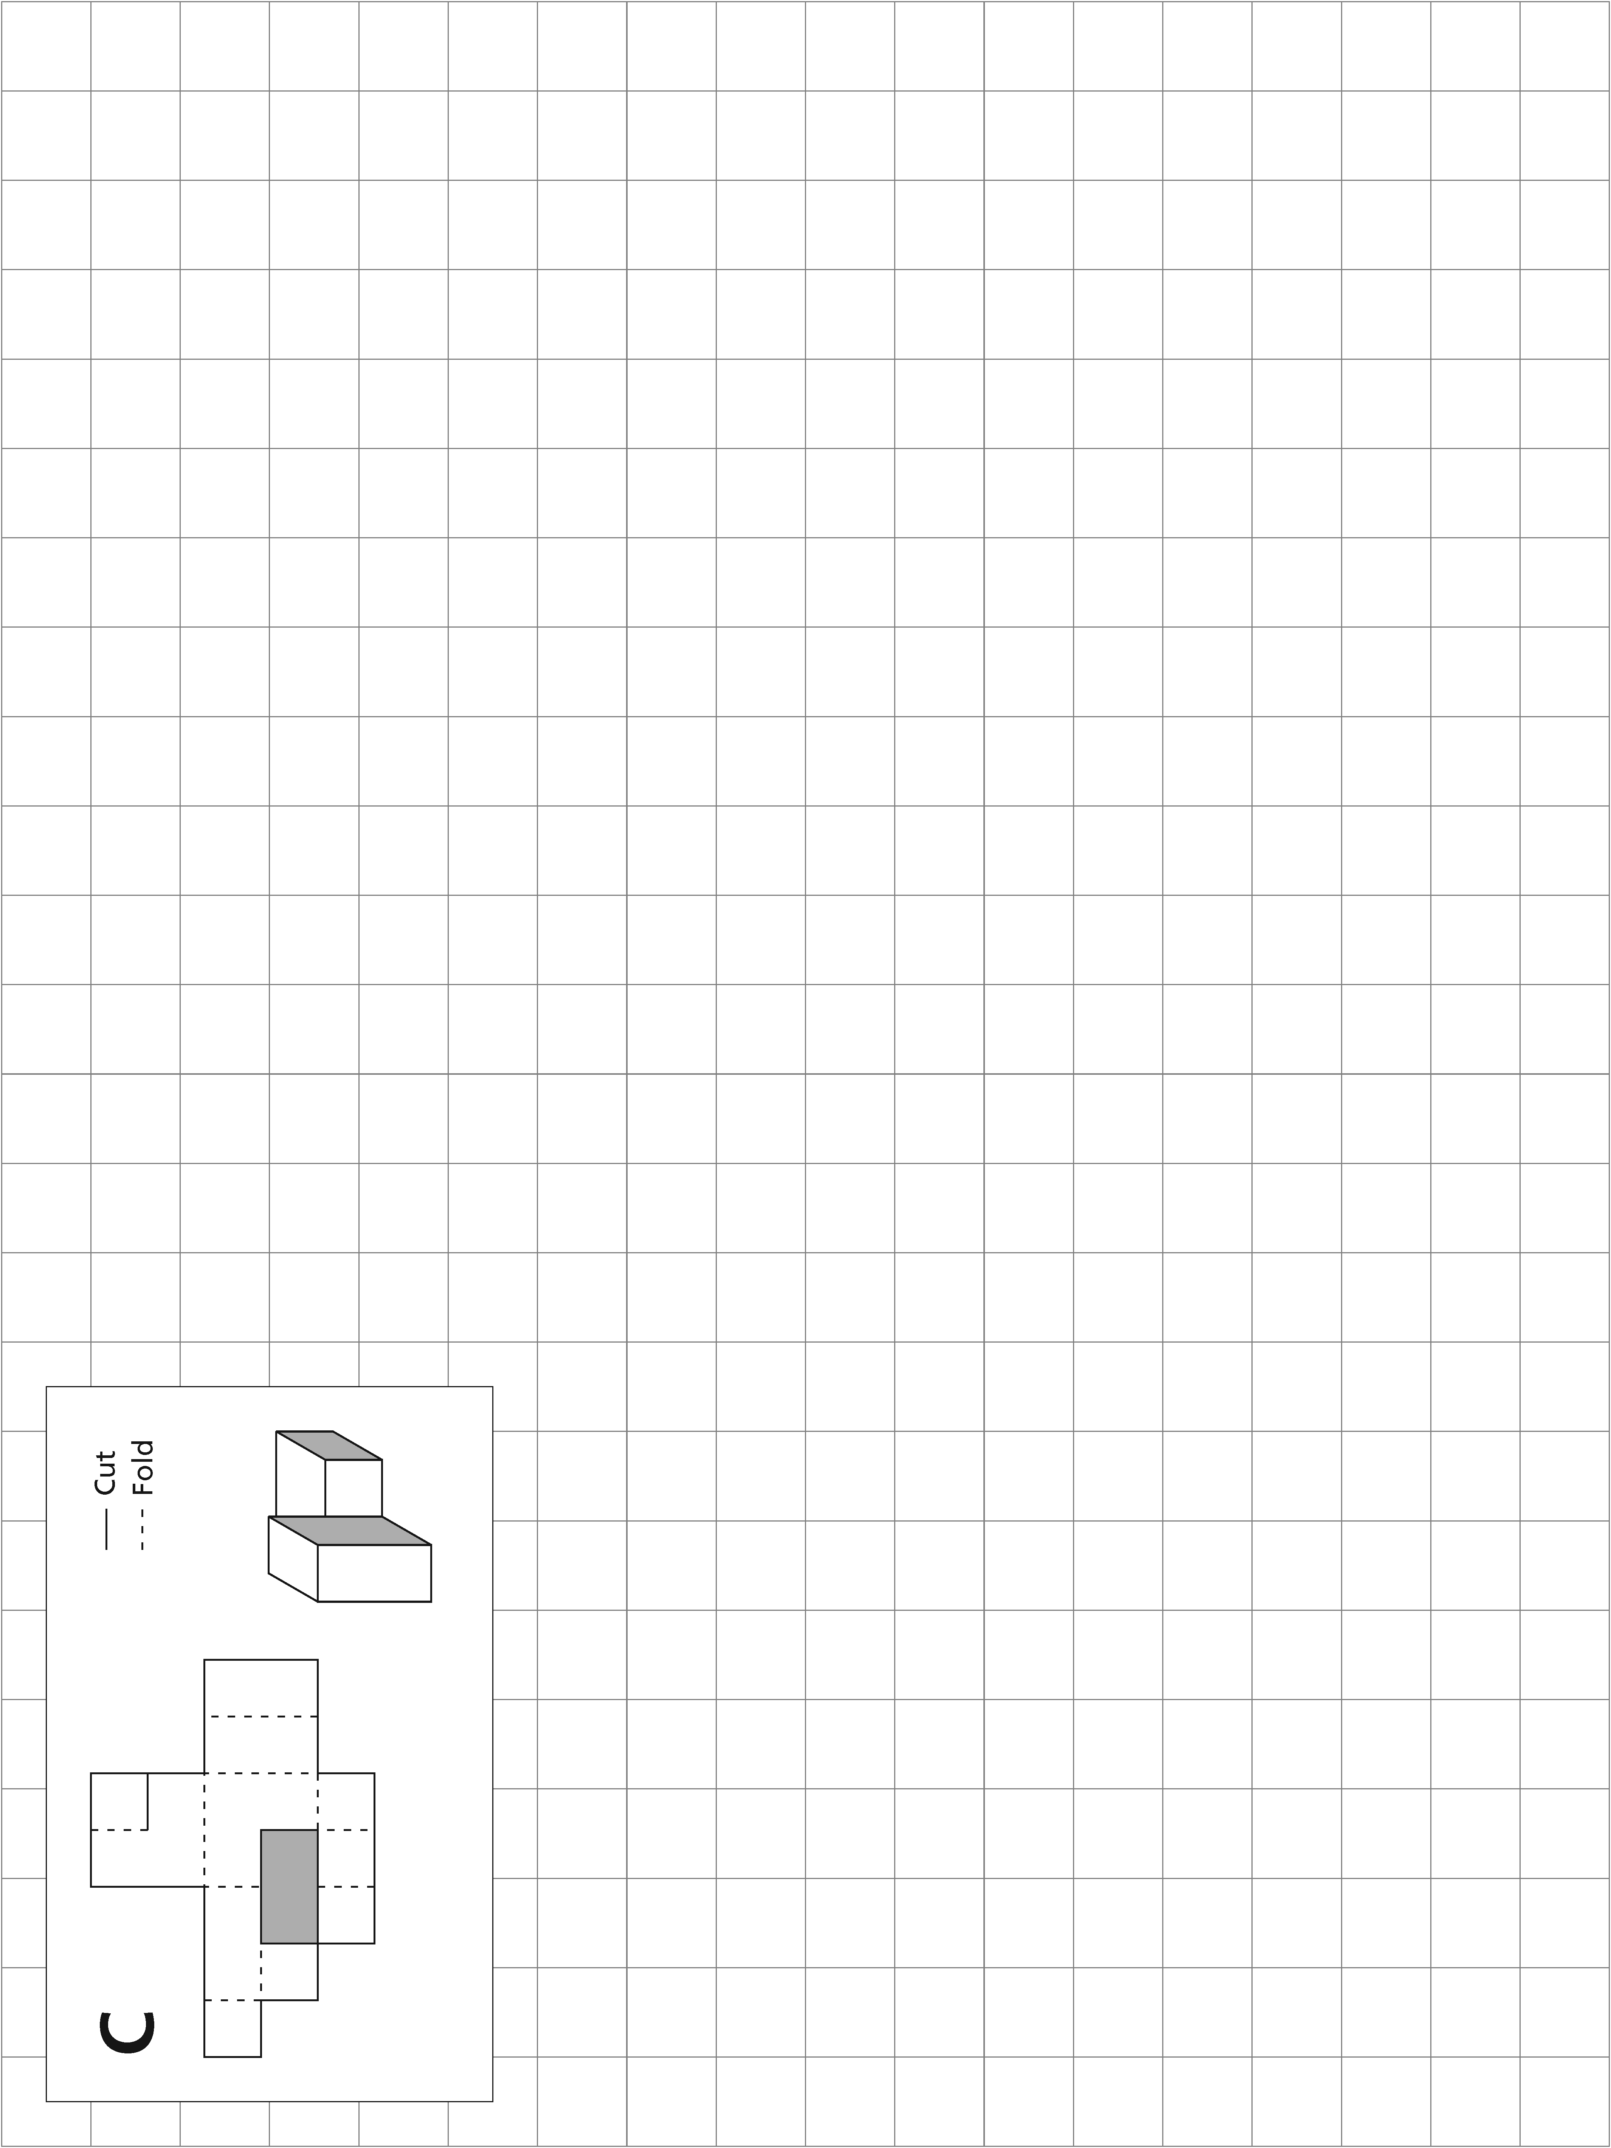

**Unit 1** The Puzzle Cube

**Lesson 2** Solving 1-Step Equations

1–48

**Unit 1** The Puzzle Cube

**Lesson 3** Solving 2-Step Equations

1–60

All measurements are in centimeters (cm).

Assume that all lines are straight and that all corners are 90 degrees.

Darkened rectangle indicates hole in template.

Not drawn to scale.

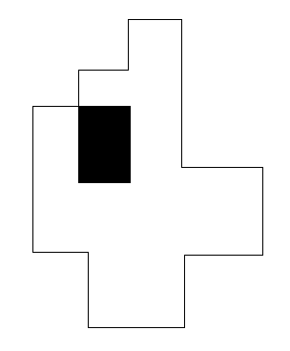

21

15

C

2*y*



9*x*

4*y*

6*x*

6*x*

4*y*

4*y*

6*x*

3

6

3



2*w* + 5

**Equation for Net C:**

|  |  |  |  |
| --- | --- | --- | --- |
| w) |  | = |  |
|  |  | = |  |
|  |  | = |  |
|  |  | = |  |
| x) |  | = |  |
|  |  | = |  |
|  |  | = |  |
|  |  | = |  |
| y) |  | = |  |
|  |  | = |  |
|  |  | = |  |
|  |  | = |  |

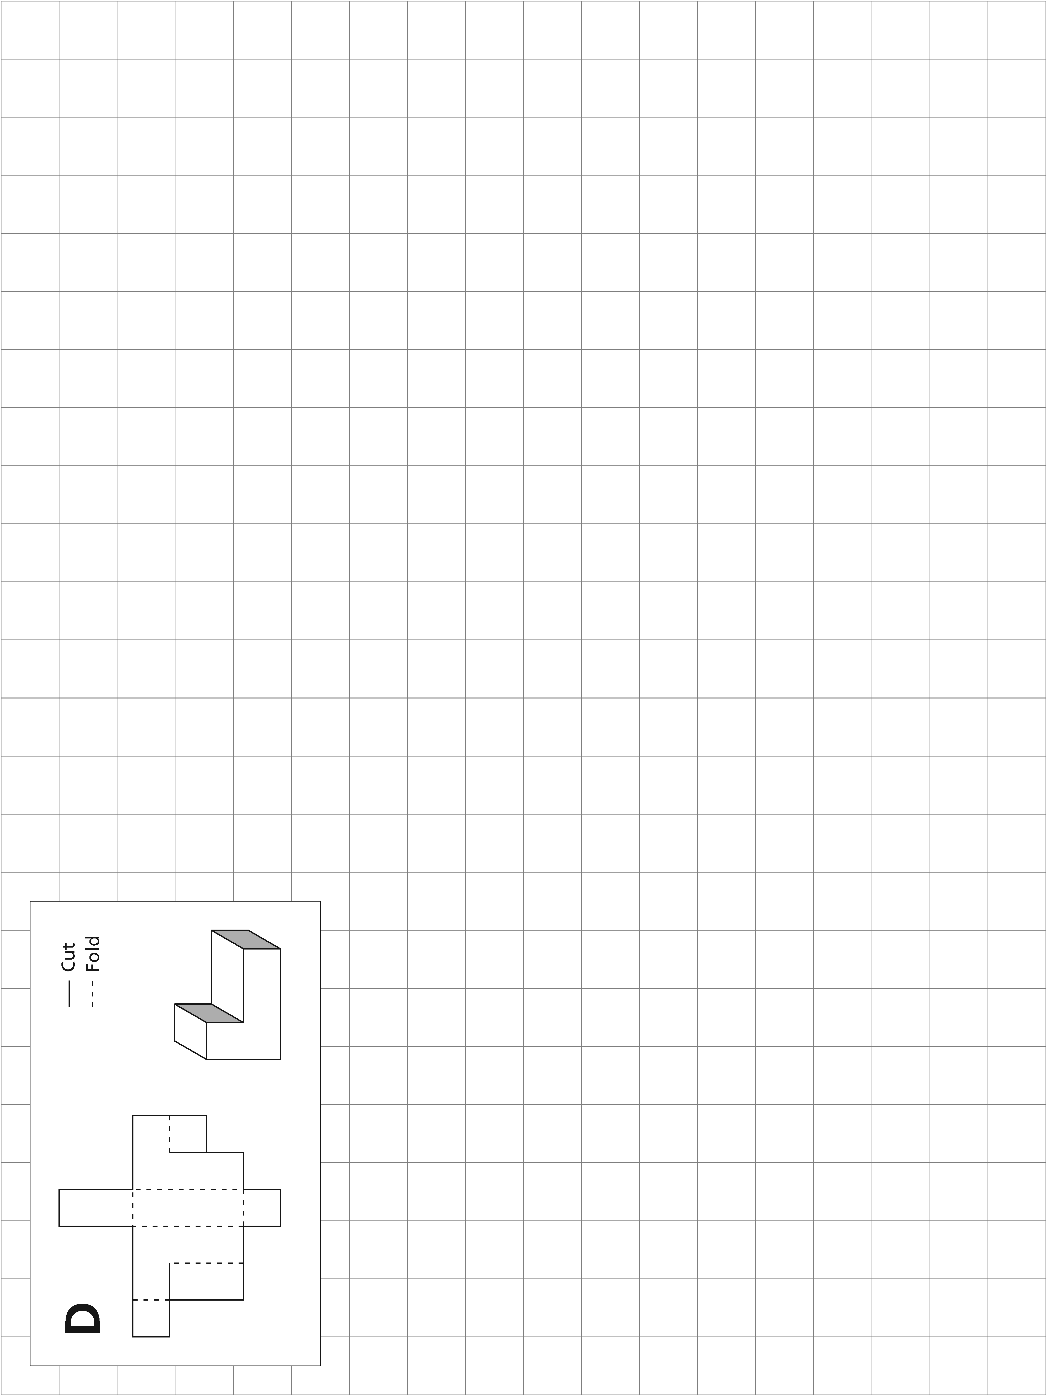

1–49



**Student Resource 4.1**

**Unit 1** The Puzzle Cube

**Lesson 4** Solving Equations with the Distributive Property

**Worksheet: Rough Sketch–Nets D and E**

**Directions**

*The following are rough sketches of nets that will fold into 3-D objects. Write an expression for the perimeter of each net and simplify that expression. Then use the given information to write an equation for each variable. Solve the equations. Finally, calculate the exact perimeter of the net.*

All measurements are in centimeters (cm).

Assume that all lines are straight and that all corners are 90 degrees.

Not drawn to scale.

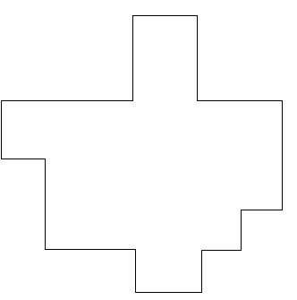

9

15

108 cm2

18   
cm2

D

*x*

*x* + 3

3

*w*

*w*

*w*

*w*

*x*

*z* − 1

*w*

3

3

3

4*y* + 2

4*y* + 2

*z −* 1

**Equation for Net D:**

|  |  |  |  |
| --- | --- | --- | --- |
| w) |  | = |  |
|  |  | = |  |
|  |  | = |  |
|  |  | = |  |
| x) |  | = |  |
|  |  | = |  |
|  |  | = |  |
|  |  | = |  |
| y) |  | = |  |
|  |  | = |  |
|  |  | = |  |
|  |  | = |  |
| z) |  | = |  |
|  |  | = |  |
|  |  | = |  |
|  |  | = |  |

|  |  |  |  |  |
| --- | --- | --- | --- | --- |
| Expression for Perimeter: | |  | | |
| Simplified Expression for Perimeter: | | |  |  |
| Perimeter: | 1–65 | | |  |

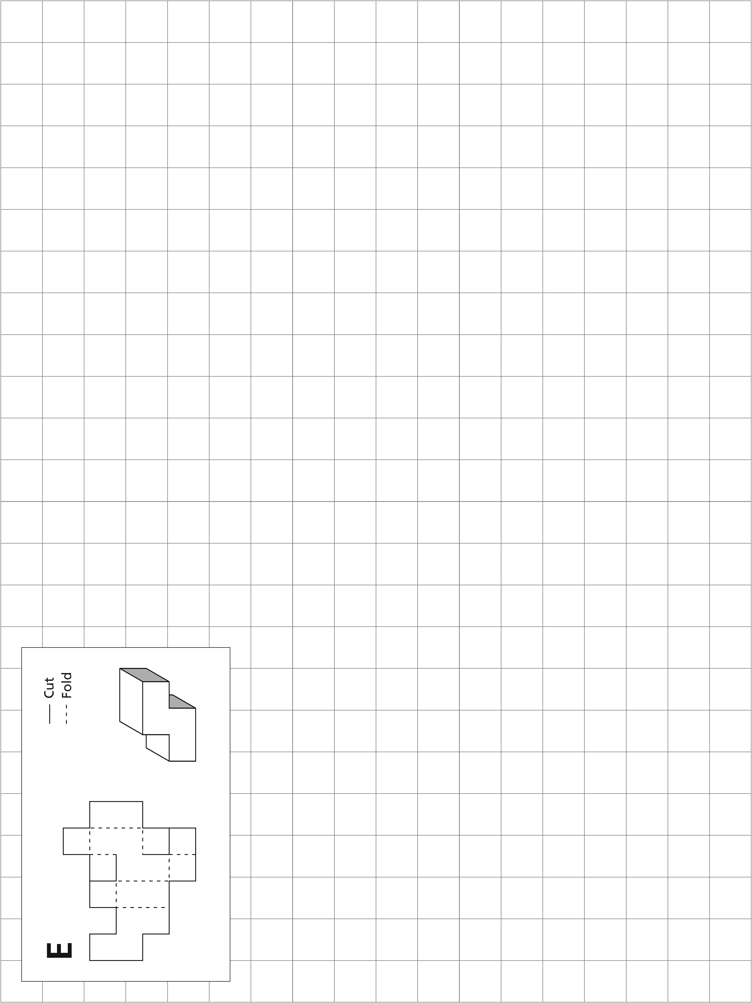

1–50



**Unit 1** The Puzzle Cube

**Lesson 4** Solving Equations with the Distributive Property

All measurements are in centimeters (cm).

Assume that all lines are straight and that all corners are 90 degrees.

Not drawn to scale.



8*y*  5

18

6













3

3

3

3

3

3

6

3*z*  10

2*x*  4

2*x*  4

*r*  9

72 cm2

36 cm2

E

3

**Equation for Net E:**

|  |  |  |  |
| --- | --- | --- | --- |
| r) |  | = |  |
|  |  | = |  |
|  |  | = |  |
|  |  | = |  |
| x) |  | = |  |
|  |  | = |  |
|  |  | = |  |
|  |  | = |  |
| y) |  | = |  |
|  |  | = |  |
|  |  | = |  |
|  |  | = |  |
| z) |  | = |  |
|  |  | = |  |
|  |  | = |  |
|  |  | = |  |

|  |  |  |  |  |
| --- | --- | --- | --- | --- |
| Expression for Perimeter: | |  | | |
| Simplified Expression for Perimeter: | | |  |  |
| Perimeter: |  | | |  |

1–66

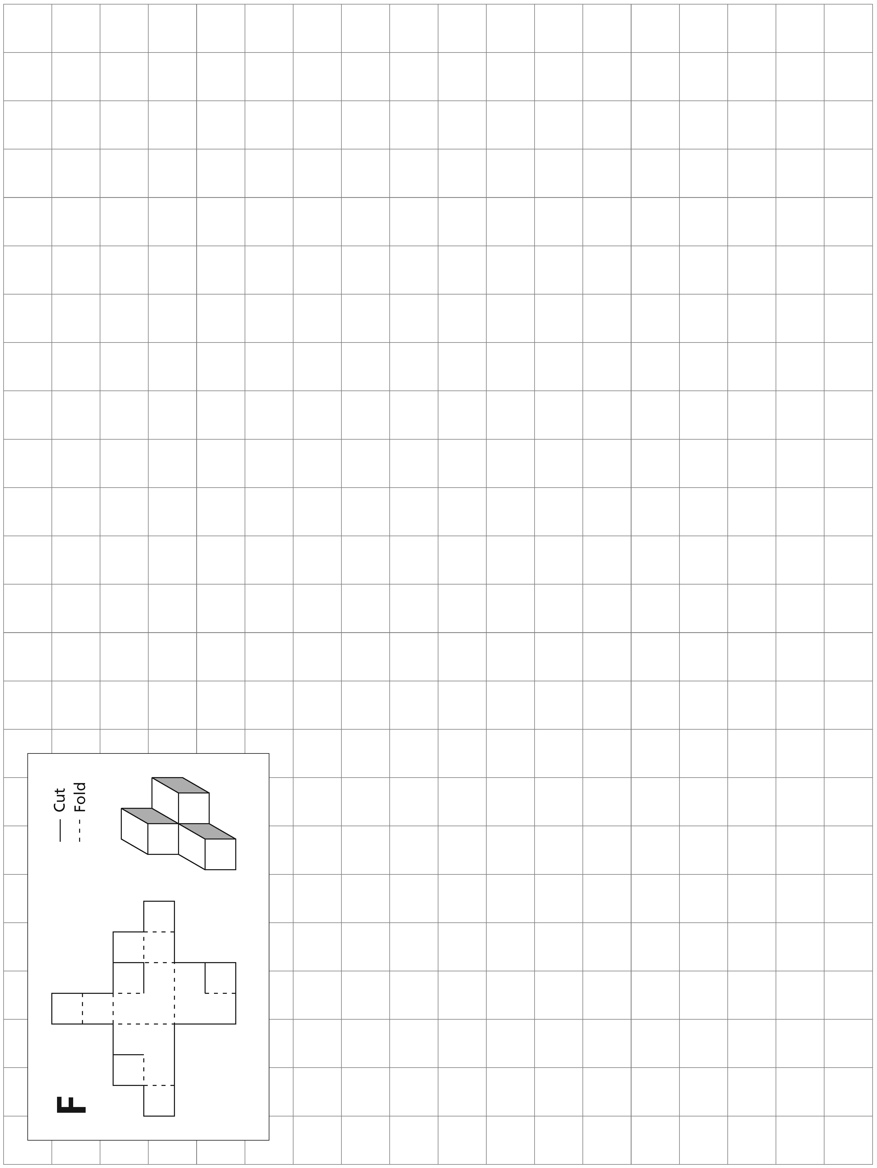

1–51



**Student Resource 5.1**

**Unit 1** The Puzzle Cube

**Lesson 5** Solving with Variables on Both Sides of the Equation

**Worksheet: Rough Sketch–Nets F and G**

**Directions**

*The following are rough sketches of nets that will fold into 3-D objects. Write an expression for the perimeter of each net and simplify that expression. Then use the given information to write an equation for each variable. Solve the equations. Finally, calculate the exact perimeter of the net.*

All measurements are in centimeters (cm).

Assume that all lines are straight and that all corners are 90 degrees.

Not drawn to scale.

**Equation for Net F:**

|  |  |  |  |
| --- | --- | --- | --- |
| w) |  | = |  |
|  |  | = |  |
|  |  | = |  |
|  |  | = |  |
| x) |  | = |  |
|  |  | = |  |
|  |  | = |  |
|  |  | = |  |
| y) |  | = |  |
|  |  | = |  |
|  |  | = |  |
|  |  | = |  |
| z) |  | = |  |
|  |  | = |  |
|  |  | = |  |
|  |  | = |  |



*x* + 12

15

*y*  2

F

(8*y* + 26) cm2

4*z*

*x*

4*z* + 3

6

3

3

3

3

3

*x*

*x*

4*z*

*x*

4*z*





|  |  |  |  |  |
| --- | --- | --- | --- | --- |
| Expression for Perimeter: | |  | | |
| Simplified Expression for Perimeter: | | |  |  |
| Perimeter: | 1–75 | | |  |

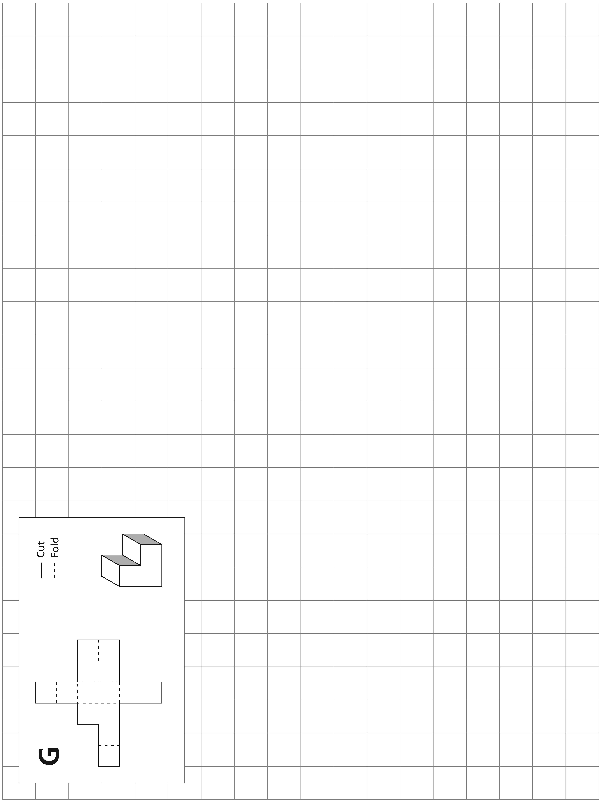

**Unit 1** The Puzzle Cube

**Lesson 2** Solving 1-Step Equations

1–52

**Unit 1** The Puzzle Cube

**Lesson 5** Solving with Variables on Both Sides of the Equation

All measurements are in centimeters (cm).

Assume that all lines are straight and that all corners are 90 degrees.

Not drawn to scale.



*y*  4

3*z*

4*x*

G

(4*y* + 8)cm2

*z*

6

3

3

3

3

2*z*  9

*z*



*z*

3*z*  9







**Equation for Net G:**

|  |  |  |  |
| --- | --- | --- | --- |
| x) |  | = |  |
|  |  | = |  |
|  |  | = |  |
|  |  | = |  |
| y) |  | = |  |
|  |  | = |  |
|  |  | = |  |
|  |  | = |  |
| z) |  | = |  |
|  |  | = |  |
|  |  | = |  |
|  |  | = |  |

|  |  |  |  |  |
| --- | --- | --- | --- | --- |
| Expression for Perimeter: | |  | | |
| Simplified Expression for Perimeter: | | |  |  |
| Perimeter: |  | | |  |

1–76